NDU
HARVEST DAY
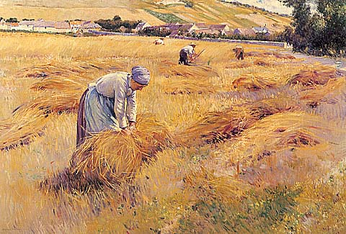

FRIENDS HALL

Friday/ Jan 20/ From 2 to 3

SBS DEPARTMENT
Selection of the best term paper of
REG 213-212

Presented by Dr clovis karam

